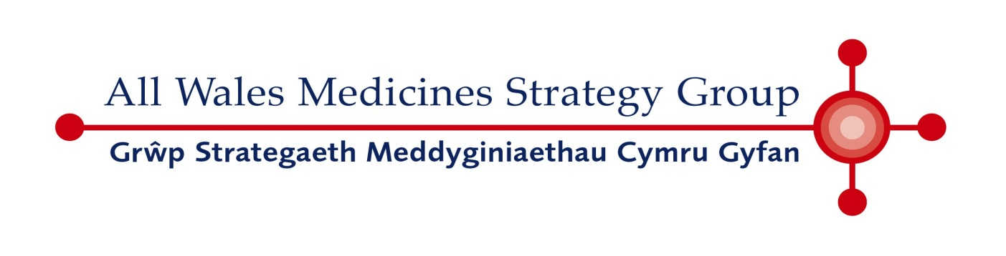

AWMSG ADVICE SUPERSEDED BY
NICE GUIDANCE (TA680)

NICE GUIDANCE ISSUED JANUARY 2021
(Refer to NICE website for full guidance on NICE recommendations, including any specific restrictions on the use of the technology)

Lenalidomide (Revlimid®) Capsule

Celgene Ltd

May 2017

Statement of Advice

In the absence of a submission from the holder of the marketing authorisation, lenalidomide (Revlimid®) cannot be endorsed for use within NHS Wales as monotherapy for the maintenance treatment of adult patients with newly diagnosed multiple myeloma who have undergone autologous stem cell transplantation.

Advice context:
The All Wales Medicines Strategy Group (AWMSG) takes into account the National Institute for Health and Care Excellence (NICE) future work programme when considering whether a product will be appraised. To avoid duplication of effort, AWMSG would not normally consider undertaking an appraisal if NICE intends to publish final technology appraisal guidance (STA/MTA/HST) for the same product and indication(s) within 12 months of the date of marketing authorisation. AWMSG guidance is interim to that of NICE, should NICE subsequently publish guidance.

The above medicine cannot be endorsed for use within NHS Wales as a technology appraisal by NICE or AWMSG has not been undertaken. The medicine should NOT be prescribed routinely within NHS Wales for the indication stated above.

In the absence of guidance issued by NICE or AWMSG, clinicians should continue to exercise their clinical judgement when providing care for an individual patient. This should be in consultation with the patient and/or guardian or carer, based on the best available evidence.

This statement will be removed on receipt of a submission (i.e. the full submission [Forms A and B] or limited submission [Forms A and C]), or updated when final NICE technology appraisal guidance becomes available.

