PATIENT ACCESS TO NICOTINE REPLACEMENT THERAPY (NRT) WHILE IN HOSPITAL – Brief Guide for Wards

Roles and responsibilities flow chart
Admission Inpatient stay Discharge
- Ensure patient receives NRT within 4 hours of admission
- Ensure patient has NRT and that “when required” medications are not locked away
- Monitor for withdrawal and flag if a review is needed (Dr / Pharmacy)
Nurse
- Ask and document smoking status
- Inform no smoking on site
- Refer smokers to SCSCP

Prescribers
- Review patients for NRT requirements
- Prescribe other pharmacotherapy as advised by SCSCP
- Ensure smoking cessation medications are added to discharge summary, where appropriate
- Advise need for withdrawal management even if patient has not chosen to quit
- Re-enforce no smoking on site
- Start initial NRT as per pathway

- Counsel patients on correct use of NRT/pharmacotherapy
- Monitor for side effects and withdrawal, changing NRT using Pharmacist Enabling Therapeutic switches policy (if appropriate)

- Ensure adequate supply of smoking cessation medication is issued to cover until follow-up appointment
- Document follow-up arrangements on discharge summary, if known
Pharmacy
- Ensure NRT is available
- Re-enforce no smoking on site

Secondary Care Smoking Cessation
Practitioners
- Arrange follow-up smoking cessation support post discharge
- Document arrangements in patient’s medical notes
- Assess patient and review pharmacotherapy options
- Advise if changes are needed (Dr/ Pharmacist)
- Provide behavioural support
- Discuss follow-on options post discharge
N.B. In the absence of a smoking cessation practitioner please refer to local protocol around referral processes to primary care services

Patients who smoke: advice to ward staff
- Inform patients that all hospital grounds are smoke free: no smoking is allowed anywhere on the hospital grounds.
- If your patient smokes (including use of e-cigarettes), follow the diagram below to support abstinence during their stay, or a quit attempt.
- Inform the patient that they can have nicotine replacement therapy (NRT) during their hospital stay.
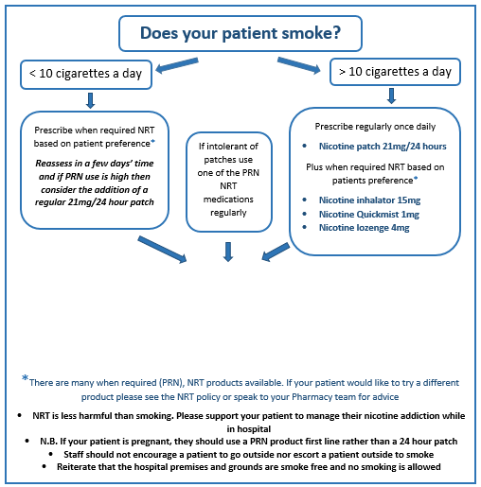

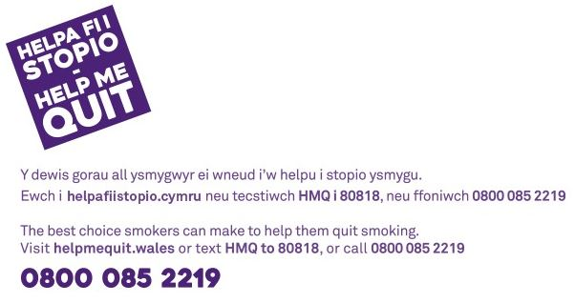
Offer ALL smokers referral to the Secondary Care Smoking Cessation Practitioner via your health board referral process:

Please add detail here for the referral process at your hospital site

When required (PRN) nicotine replacement therapy
 | Product | Preparations | Dosing regimen | How does it work? | Benefits | Cautions | Side effects
When required (PRN) nicotine preparations | Mini Lozenge | 1.5 mg available in mint flavour only and 4 mg  available in mint and fruit flavours | <20 cigarettes per day  1.5 mg lozenge every 1-2 h when urge to smoke  >20 cigarettes per day  4 mg lozenge every 1-2 h when urge to smoke | Nicotine is absorbed through lining of mouth/tongue | Smokers looking for discreet and fast craving relief | Nicotine can cause gastric irritation, therefore caution in peptic ulcer disease.  Concurrent acidic drinks (e.g. coffee, fruit juice) can decrease nicotine adsorption | Indigestion  Dry mouth
When required (PRN) nicotine preparations | Inhalator | 15 mg cartridge | When the urge to smoke occurs or to prevent cravings | Nicotine vapour is absorbed directly through lining of mouth (lasts 40 minutes) | Smokers looking for a substitute for the hand-to-mouth action of smoking | Take care with obstructive lung disease or chronic throat disease | Sore throat  Dry mouth
When required (PRN) nicotine preparations | Oral spray | 1 mg metered dose  Available in cool mint or cool berry flavours | 1-2 sprays in mouth when urge to smoke or to prevent cravings | Nicotine is absorbed through lining of mouth (quick acting - 60 seconds) | Smokers looking for discreet and fast craving relief | Nicotine can cause gastric irritation, therefore caution in peptic ulcer disease. Concurrent acidic drinks (e.g. coffee, fruit juice) can decrease nicotine adsorption | Sore throat and hiccups if sprays at back of throat  Excessive salivation  Watery eyes

What is nicotine replacement therapy (NRT)?
NRT is intended to replace the nicotine a patient would usually rely on from a cigarette by providing it in an alternative form while they are on hospital premises. Patients should be advised that most warnings for continued smoking also apply to NRT, but the level of risk associated with continued smoking outweighs any risks of using NRT.

Nicotine withdrawal signs and symptoms include:
- urges
- anxiety or depression
- aggression
- increase in appetite
- inability to concentrate
- sleepiness or sleeplessness
- mouth ulcers
- constipation.

For more information on NRT and smoking cessation, contact your Pharmacy Lead or Secondary Care Smoking Cessation Practitioner (SCSCP) / Help Me Quit Advisor.

Pharmacy leads
Site | Pharmacy Lead

SCSCP / Help Me Quit advisors

